Detailed Statistical Report and Interpretation
Bacterial Isolation and Profiling of Selected Poso Spout Samples
Prepared by | Engr. Jamie Eduardo Rosal, MSCpE
Analysis platform | Python computations in Jupyter Notebook
Primary dataset | Encoded observations from RESEARCH RESULTS.pdf
Report date | May 03, 2026

Abstract
This report presents a descriptive statistical analysis of bacterial profiling results from selected poso spout samples. The analysis was conducted using a structured encoding of laboratory observations, including growth status, Gram reaction, cultural characteristics, selective and differential media outcomes, and biochemical test results. Because the data are primarily categorical, the appropriate statistical treatment consists of frequency counts, percentages, cross-tabulations, binary profile matrices, and site-similarity summaries. The results support descriptive comparison across sampling sites, while species-level identification and microbial-load inference remain presumptive and limited without confirmatory identification methods or numeric CFU data.

Dataset and Analytical Scope
The dataset contains 18 encoded sample records representing coded poso samples A-1 to F-3. Of these, 15 samples contained usable recorded laboratory observations, while three samples under Poso E were blank or missing in the results sheet. All percentages for morphological, cultural, and biochemical summaries were therefore computed using the 15 recorded samples unless otherwise stated.
Metric | Value
Total encoded samples | 18
Samples with recorded results | 15
Samples with missing/blank results | 3
Sites represented | A, B, C, D, E, F
Sites with complete recorded replicates | A, B, C, D, F
Table 1. Dataset audit and completeness summary.
Statistical note: ANOVA is not valid for the current dataset because the available observations are categorical. ANOVA would require numeric microbial-load measurements such as colony counts, dilution factors, swabbed area, and computed CFU/cm².

Objective-Level Answerability
The computations directly support the descriptive objectives of the study. The laboratory act of isolating bacteria is not computational, but the notebook can summarize recorded growth after isolation. Cultural, morphological, biochemical, and between-site profile comparisons are answerable using the encoded categorical results.
Objective | Answerable With Notebook | What Notebook Can Answer | Limitation
1. Isolate bacterial microorganisms from swabbed samples | Partly | Summarize recorded growth/presence after lab isolation. | Actual isolation is a wet-lab procedure and cannot be done computationally.
2. Determine cultural and morphological characteristics | Yes | Frequency and percentage summaries for Gram stain, morphology, colony/media characteristics, and hemolysis. | Depends on accuracy/completeness of encoded lab observations.
3. Identify biochemical characteristics | Yes, descriptively | Summarize TSI, SCA, SIM, MR, VP, catalase, coagulase, and oxidase results. | Exact species identification remains presumptive without confirmatory identification tests.
4. Compare bacterial profiles among sampling sites | Yes, with missing-data caveat | Compare profiles by site using crosstabs, percentages, binary profile matrices, and similarity scores. | Site E is blank/missing; categorical data are not suitable for ANOVA unless numeric CFU/microbial-load data are added.
Table 2. Objective-level statistical answerability.

Results and Interpretation

Recorded Growth
Bacterial growth was recorded in 15 of 18 encoded samples, corresponding to 83.33% of all sample entries. The remaining 16.67% were missing because Poso E-1, E-2, and E-3 did not contain recorded observations. Interpreted conservatively, the available results show that bacterial growth was commonly detected among the sampled poso spouts with completed laboratory records.
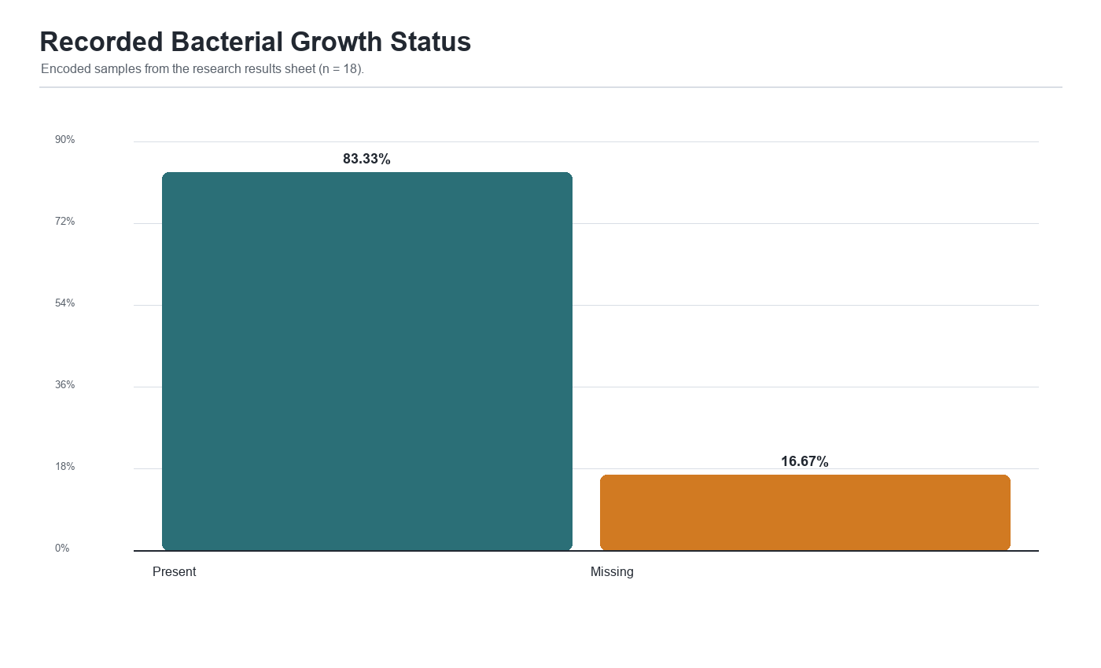
Figure 1. Recorded bacterial growth status across encoded samples.

Gram Reaction and Morphology
Among the 15 recorded samples, Gram-negative organisms predominated. Gram-negative results accounted for 11 samples or 73.33%, Gram-positive results accounted for 3 samples or 20.00%, and one sample or 6.67% was encoded as Gram-variable. This distribution indicates that the observed profiles were largely dominated by Gram-negative bacilli or related Gram-negative forms, consistent with the frequent growth and fermentation observations recorded on selective and differential media.
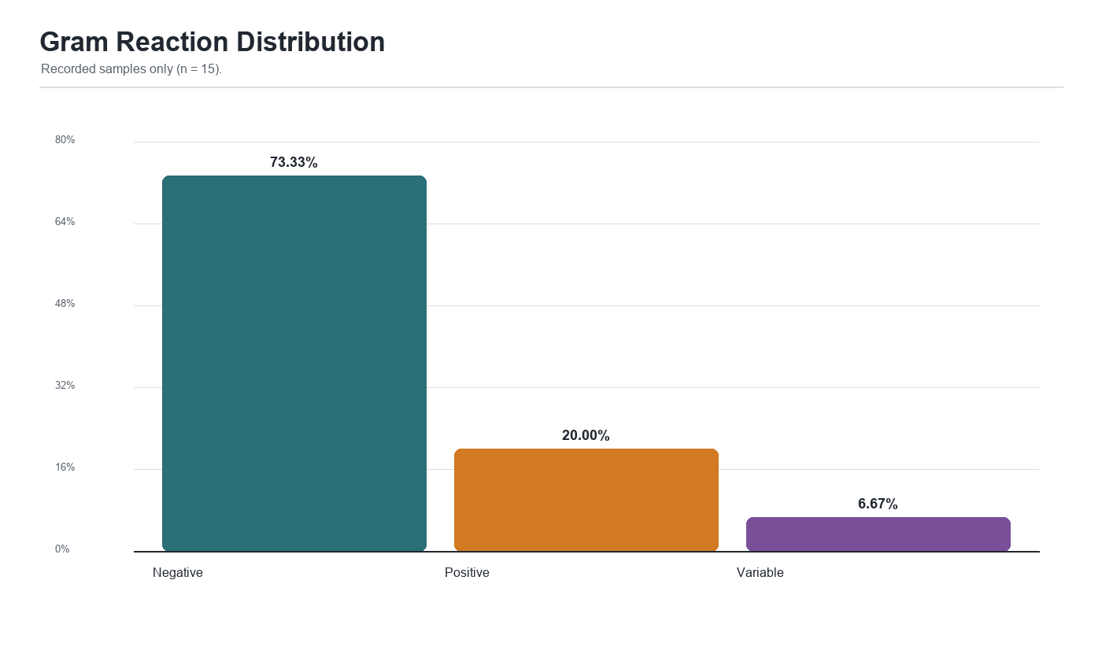
Figure 2. Distribution of Gram reaction among recorded samples.
Gram Reaction | Count | Percent
Negative | 11 | 73.33
Positive | 3 | 20.0
Variable | 1 | 6.67
Table 3. Frequency and percentage distribution of Gram reaction.

Cultural and Media-Based Characteristics
MacConkey, EMB, MSA, SSA, and BAP results were used to summarize cultural characteristics and likely functional groups. Several samples showed lactose-fermenting or strong lactose-fermenting reactions, while others were repeatedly categorized as non-lactose fermenters. Metallic green sheen on EMB, where present, was treated only as a presumptive coliform or possible E. coli indicator. The report avoids definitive species claims because confirmatory identification methods were not provided.
Test | Result | Count | Percent
mac_lactose | Non-lactose fermenter | 8 | 53.33
mac_lactose | Lactose fermenter | 5 | 33.33
mac_lactose | Mixed | 2 | 13.33
mannitol | Negative | 10 | 66.67
mannitol | Positive | 2 | 13.33
mannitol | Not applicable | 2 | 13.33
mannitol | Indeterminate | 1 | 6.67
emb_metallic_sheen | No | 10 | 66.67
emb_metallic_sheen | Yes | 5 | 33.33
emb_lactose | Non-lactose fermenter | 9 | 60.0
emb_lactose | Strong lactose fermenter | 3 | 20.0
emb_lactose | Lactose fermenter | 2 | 13.33
emb_lactose | Indeterminate | 1 | 6.67
ssa_lactose | Non-lactose fermenter | 10 | 66.67
ssa_lactose | Lactose fermenter | 2 | 13.33
ssa_lactose | Mixed | 2 | 13.33
ssa_lactose | Not tested | 1 | 6.67
Table 4. Summary of selected media-based cultural characteristics.

Biochemical Characteristics
The biochemical results show a high frequency of motility-positive observations, with 13 of 15 recorded samples encoded as motile. H2S production was not observed in the encoded records. MR-positive or weak-positive reactions were present in several samples, while VP positivity was absent. Catalase, coagulase, and oxidase results varied by site and sample, supporting the conclusion that the poso spouts did not show a single uniform bacterial profile.
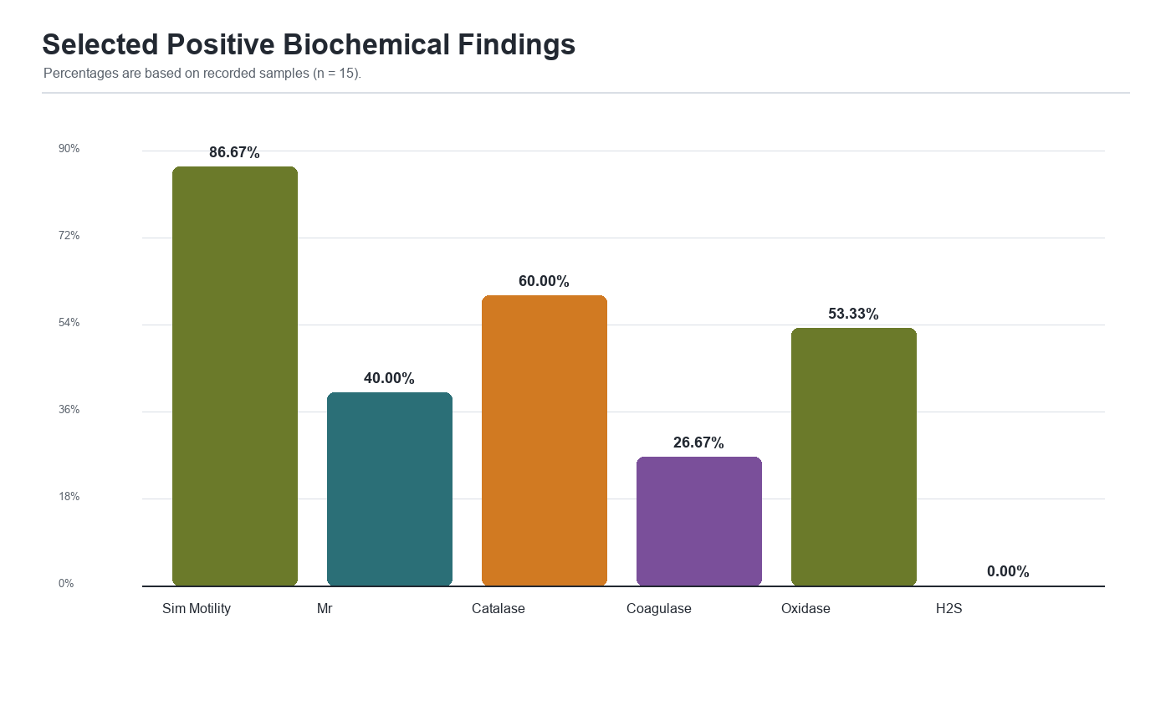
Figure 3. Selected positive biochemical findings among recorded samples.
Test | Result | Count | Percent
tsi | Not recorded | 5 | 33.33
tsi | Not tested | 4 | 26.67
tsi | K/K | 4 | 26.67
tsi | A/A | 2 | 13.33
sca | Not tested | 4 | 26.67
sca | Positive | 4 | 26.67
sca | Negative | 4 | 26.67
sca | Not recorded | 3 | 20.0
sim_motility | Positive | 13 | 86.67
sim_motility | Not tested | 1 | 6.67
sim_motility | Negative | 1 | 6.67
mr | Negative | 7 | 46.67
mr | Positive | 6 | 40.0
mr | Weak positive | 1 | 6.67
mr | Not tested | 1 | 6.67
vp | Negative | 14 | 93.33
vp | Not tested | 1 | 6.67
catalase | Positive | 9 | 60.0
catalase | Negative | 5 | 33.33
catalase | Not recorded | 1 | 6.67
coagulase | Negative | 8 | 53.33
coagulase | Positive | 4 | 26.67
coagulase | Not tested | 2 | 13.33
coagulase | Not recorded | 1 | 6.67
oxidase | Positive | 8 | 53.33
oxidase | Negative | 4 | 26.67
oxidase | Not tested | 2 | 13.33
oxidase | Not recorded | 1 | 6.67
h2s | Negative | 15 | 100.0
Table 5. Descriptive summary of biochemical test outcomes.

Between-Site Profile Comparison
Site-level comparison was performed using binary feature rates. Poso A and C were fully Gram-negative among recorded replicates, while Poso B and D showed mixed Gram-reaction patterns. Poso F showed a mixed profile because one replicate was Gram-variable and other replicates showed Gram-negative interpretations. Site E was excluded from substantive comparison because all three entries were blank. The feature-rate matrix indicates that motility was common across A, C, and F, while catalase positivity was prominent in B, D, and F. Oxidase positivity was strongest in C and F based on the encoded records.
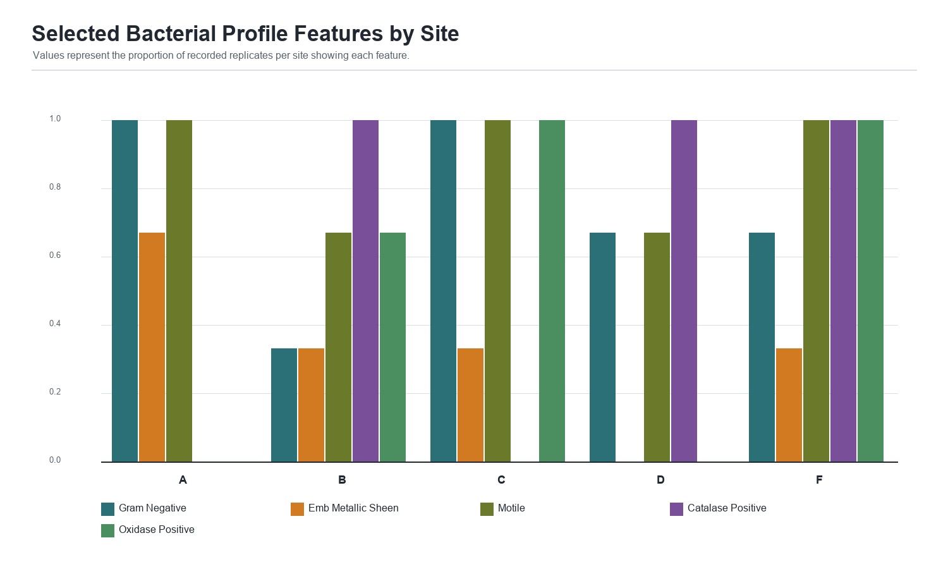
Figure 4. Selected bacterial profile features by site.
Site | Gram Negative | Gram Positive | Mac Lactose Fermenter | Mac Non Lactose Fermenter | Emb Metallic Sheen | H2S Positive | Motile | Mr Positive | Vp Positive | Catalase Positive | Coagulase Positive | Oxidase Positive
A | 1.0 | 0.0 | 0.67 | 0.33 | 0.67 | 0.0 | 1.0 | 0.67 | 0.0 | 0.0 | 0.0 | 0.0
B | 0.33 | 0.67 | 0.33 | 0.67 | 0.33 | 0.0 | 0.67 | 0.33 | 0.0 | 1.0 | 0.67 | 0.67
C | 1.0 | 0.0 | 0.33 | 0.0 | 0.33 | 0.0 | 1.0 | 1.0 | 0.0 | 0.0 | 0.0 | 1.0
D | 0.67 | 0.33 | 0.0 | 1.0 | 0.0 | 0.0 | 0.67 | 0.0 | 0.0 | 1.0 | 0.67 | 0.0
F | 0.67 | 0.0 | 0.33 | 0.67 | 0.33 | 0.0 | 1.0 | 0.33 | 0.0 | 1.0 | 0.0 | 1.0
Table 6. Site-level binary feature rates.

Profile Similarity
Jaccard similarity was used as a descriptive measure of overlap among encoded binary site profiles. The highest off-diagonal similarity was observed between Poso B and Poso F at 0.80, followed by several comparisons involving Poso F and Poso A or C at 0.75. Poso D showed lower similarity with Poso C at 0.20, indicating a more distinct categorical profile in the encoded dataset. These values should be read as descriptive similarity indicators rather than inferential tests.
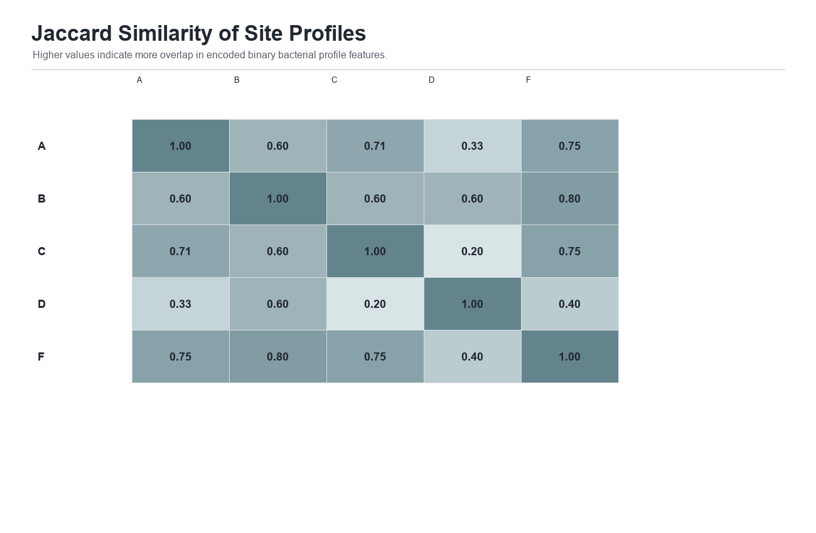
Figure 5. Jaccard similarity heatmap of site profiles.

Presumptive Indicator Findings
Several samples contained patterns that may suggest indicator or opportunistic bacterial groups. For example, EMB metallic green sheen was encoded as a possible E. coli or coliform indicator, while catalase-positive and coagulase-positive profiles were treated as possible Staphylococcus aureus indicators. These interpretations are intentionally conservative. They should be described as presumptive because the dataset does not include molecular confirmation, automated identification, MALDI-TOF, API identification, or other validated confirmatory methods.
Sample Id | Site | Presumptive Flags
A-1 | A | Gram-negative non-lactose fermenter; motile; H2S-negative
A-2 | A | Possible E. coli/coliform indicator based on EMB metallic sheen; citrate-positive; motile
A-3 | A | Possible E. coli/coliform indicator based on EMB metallic sheen; MR-positive; motile
B-1 | B | Possible Staphylococcus aureus indicator based on catalase/coagulase positivity; EMB suggests lactose fermenter
B-2 | B | Possible Staphylococcus aureus indicator; citrate-positive; motile; non-lactose fermenter
B-3 | B | Gram-negative non-lactose fermenter; catalase-positive; oxidase-negative
C-1 | C | Mixed MAC growth; possible non-lactose fermenter; oxidase-positive; possible Shigella noted in source
C-2 | C | Possible E. coli indicator based on EMB metallic sheen; mixed MAC growth; oxidase-positive
C-3 | C | Lactose fermenter on MAC/SSA; citrate-positive; oxidase-positive; MR-positive
D-1 | D | Non-lactose fermenter; catalase/coagulase-positive; oxidase-negative
D-2 | D | Non-fermenter profile; catalase/coagulase-positive; oxidase-negative; non-motile
D-3 | D | Gram-positive cocci; catalase-positive; coagulase-negative; oxidase-negative
F-1 | F | Gram-negative bacilli; MAC lactose fermenter; motile; oxidase-positive
F-2 | F | Gram-variable but likely Gram-negative bacilli; non-lactose fermenter; citrate-positive; oxidase-positive
F-3 | F | Possible E. coli/coliform indicator based on EMB metallic sheen; MR-positive; oxidase-positive
Table 7. Presumptive indicator flags from encoded laboratory observations.

Statistical Suitability and Limitations
Planned Analysis | Suitable With Current Data | Reason | Needed To Make It Suitable
ANOVA for microbial load comparison | No | The encoded results are categorical observations, not numeric CFU or microbial-load measurements. | Add numeric colony counts, dilution factors, swabbed surface area, and computed CFU/cm^2 or comparable microbial-load values.
Frequency counts and percentages | Yes | The results are mostly present/absent, positive/negative, and categorical media observations. | No additional numeric data required, but missing entries should be completed where possible.
Chi-square or Fisher exact tests | Limited | The sample size is small and Site E is missing; many expected counts may be too low. | More complete samples per site or a narrower categorical comparison.
Table 8. Suitability of planned statistical methods.
The principal limitation is the categorical nature of the result sheet. Counts and percentages are appropriate; inferential testing is restricted by small sample size, incomplete Site E records, and absence of numeric microbial-load data. Any future ANOVA or microbial-load comparison should add CFU counts, dilution factors, swabbed area, and standardized units. In addition, inconsistent or ambiguous laboratory interpretations should be validated by qualified microbiology personnel before final species-level discussion.

Conclusion
The Jupyter- python based computations successfully answer the descriptive components of the research objectives. The encoded results demonstrate frequent bacterial growth among completed samples, predominance of Gram-negative profiles, diverse media and biochemical reactions, and observable differences among poso sampling sites. The analysis supports a scholarly Chapter 4-style presentation using descriptive statistics, tables, and figures. However, the study should avoid overstating definitive species identification or microbial-load differences unless additional confirmatory and quantitative data are provided.

Recommended Chapter 4 Statement
Based on the encoded laboratory records, bacterial growth was observed in most completed poso spout samples. Descriptive analysis showed that Gram-negative bacteria represented the largest proportion of recorded isolates, while biochemical and media-based reactions varied across sites. These findings indicate heterogeneity in bacterial profiles among selected poso spouts. Because the results are categorical and some site records are incomplete, the analysis is best interpreted descriptively through frequencies, percentages, and site-profile comparisons rather than through ANOVA or microbial-load inference.

